

You will notice that your child has a login for Sumdog in their bag. We have been using this exciting and interactive maths site successfully in school for a few years now. It allows the children opportunities to develop their mental recall strategies and tracks their progress, setting applicable challenges as the children progress. As teachers, we are able to set the children challenges that link directly to the work we are doing in school. We also use this site in school at times during our IT lessons and as the children come into school, so if you do not have a computer your child can use they will still be able to access it. We do encourage you to sign your child up for Sumdog and to allow them to use it at home, however please note that this is not a set homework and it is at your discretion whether they use it and for how long.

Year 1

It’s hard to believe that we’ve reached the end of our first half term already and what a busy one it has been! We have lots planned for the next half term, which promises to be just as busy.

**Club 99**

Some children began their club 99 challenge this week. This is a maths challenge we run throughout the school. The children have 10 minutes to complete their weekly challenge and in year 1, this will be every Tuesday during our maths lesson. Once they have completed a challenge they will move up the leader board and will earn a badge, which we encourage them to wear in school. When they complete the next challenge, they return the badge in exchange for the next badge. The children really enjoy Club 99 and it has proved very successful in developing quick mental recall of number facts. We will send a practice sheet home each week.

**Spellings**

Some children took a long spelling test this week. We have used the results of this spelling test to allow us to give the children appropriate spellings to learn each week. They have the half terms spellings in their bag today, broken down into weekly sets of words for them to practice. We will also send home a Look, Say, Cover, Write, Check sheet for them to practice each week.



**Handwriting**

As you are aware, we are teaching the children to write using the cursive font. They are being taught how to write in this style every day in school and to help us to embed this please encourage your child to use the letters they have learnt in school when writing at home. Every letter begins on the line.

a b c d e f g h i j k l m n o p q r s t u v w x y z

**London**

Our topic next term is Bright Lights, Big City and focuses on London. We have already arranged a communication with a school in London and plan for the children to send emails and write letters to these children exploring the similarities and differences between the locations they live in. We are very excited about all the learning we have planned.

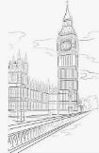

**Half Term Homework**

As part of our London topic, we will be looking at the Great Fire of London. As part of this work we would like the children to build a small house (no bigger than a shoe or cereal box please). We would like them to bring these in on the first day back where all our learning will focus on Samuel Peypes and the Great Fire of London. Please do not make beautiful masterpieces as out intent is to set the houses on fire so the children can see how the fire spread.

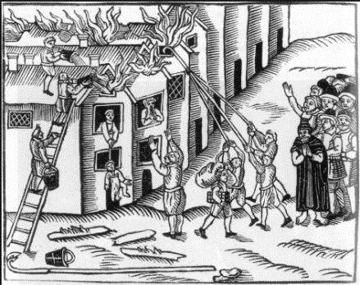

**Remembrance**

This year marks the 100th anniversary of the end of the First World War and as a school, we be celebrating and learning about this and the meaning of Remembrance Sunday. In Year 1, we will look at some age appropriate poetry and stories about World War 1 throughout the week and on Friday 9th November, we will have a day of Remembrance, where we will carryout a variety of activities. This will include a talk from Miss Cocks’ Dad who collects Wartime memorabilia and will share some of his expert knowledge with the children.

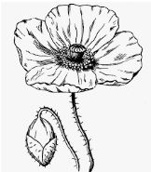

We wish you all a happy and restful half term.

Gill Brotherhood & Sophie Cocks